

Real-Time ScoreBoard Project Assessment

Feasibility Study



1st August

R&D Students

AUT

**Team Members**

Hayley-Belle Cleverdon   
Vinicius Alves Ferreira  
Karanjit Gahunia   
Seung-Kyu Jin   
Alex Lu

**Client**

Dr. Robin Hankin

**Supervisor(s)**

Nikola Kasabov

Akshay Raj Gollahalli

**Moderator:**

Dr. Stephen Thorpe

Version

Feasibility Study Version 1.0

Contents

Project Description 3

Project Overview 3

Technical Assessment 4

Venue Infrastructure 4

Venue Information 4

Networks 5

Existing Equipment 7

Hardware requirements 8

Hardware specifications 10

Other Elements of an in-house Implementation 13

Cloud Solutions 14

Web Hosting 14

Amazon 15

Cloudflare 15

Existing Solutions 16

Estimated Costs 16

Solution Summary 17

System Implementation 18

Application Solutions 20

Operational Assessment 22

Hardware Approach (Original) with Web-Based application solution 22

Cloud Approach with Web-Based application solution 22

Physical Scoreboard with Cloud 23

Scorer Option 23

Legal Assessment 25

ASB Stadium Sports Venue 25

Licensing 26

Resource and Schedule study 27

Conclusion 28

# **Project Description**

This project is a Research and Development project assigned by the Computing and Information Sciences Faculty of Auckland University of Technology (AUT). Dr. Robin Hankin, a lecturer at AUT, proposed the project on behalf of the Auckland Mathematics Association (AMA), who are key stakeholders in the project.

Dr. Hankin has asked that we provide an in-depth feasibility study and at least a presentable prototype for a real-time online scoreboard to be used during MATHEX events run by the AMA. This scoreboard would be used alongside the current pen-and-paper system, and aims to improve the experience that audience members have during the event, by allowing them to view the scores of each team as the competition is underway.

The feasibility study, along with all other project documentation, should provide enough information that another group of students could carry on with the project at a later date. The prototype can be presented to AUT as evidence of our development skills, as well as provide a working version of the solution for the AMA’s consideration.

# **Project Overview**

**Project Objective**

Our project objective is to create and implement a Real Time Online Scoreboard System into the Casio MATHEX competition within 1 year and at a cost which does not exceed $20,000.

**Project Scope**

Our project scope has two major sections. The first section aims to produce a feasibility report which investigates whether the production and implementation of the scoreboard within the one year time frame is achievable. If the feasibility report reveals that the project cannot be completed in a year, then we will produce a Project Roadmap which details the project processes and tasks necessary to design, create and implement the scoreboard successfully into the MATHEX competition in case of project hand off.

The second section aims to produce the hardware and software for the Real Time Online Scoreboard system. This system will improve the attendee and participant’s experience by making it easier to keep track of the competition’s scores as well as streamline the judging process. Initially, a prototype for the system will be produced which will attempt to showcase and incorporate as many of the client’s requirements as possible.

# **Technical Assessment**

This assessment aims to inform and advise the client (as well as future teams undertaking this project, if this is the case) of the technical needs and solutions for the project under discussion.

This assessment consists of an analysis of 3 main areas:

1. The venue’s infrastructure and existing hardware.
2. The hardware solution evaluation.
3. The cloud based solution evaluation.

At last a recommendation is given based on the information presented in each section. It aims to address the best resolution to the problem domain.

**Venue Infrastructure**

Note that most of the information in this report was obtained on a visit to the ASB Stadium by Karanjit Gahunia on the 30th of June. Brian Tomlinson, the general manager of ASB Stadium, was interviewed during this visit. The findings are based on the interview as well as observations made on this visit. Photos were taken during this visit and Mr Tomlinson has given permission to use those photos in this report.

### **Venue Information**

**Venue Size**

The Auckland MATHEX events are held at the ASB Stadium in Kohimarama. The main gym is used for this event which spans over 2 days, with 2 sessions each day. The main gym floor is 45m × 30m (1350 sq/m) and has a floor above with seating for approximately 3500 people. In previous MATHEX events, there have been approximately 5000 people in attendance each day (between the 2 sessions). The amount of people attending these events has been increasing.

**Unused Seating Section**

The layout of MATHEX competitions at ASB Stadium can be seen in figure 1. In previous years, the seating section behind the markers has been completely closed off (figure 2). This is to prevent spectators from cheating by seeing the answer sheets that the markers have. However, in recent years, higher rows of seating have been opened due to high attendance at these events.

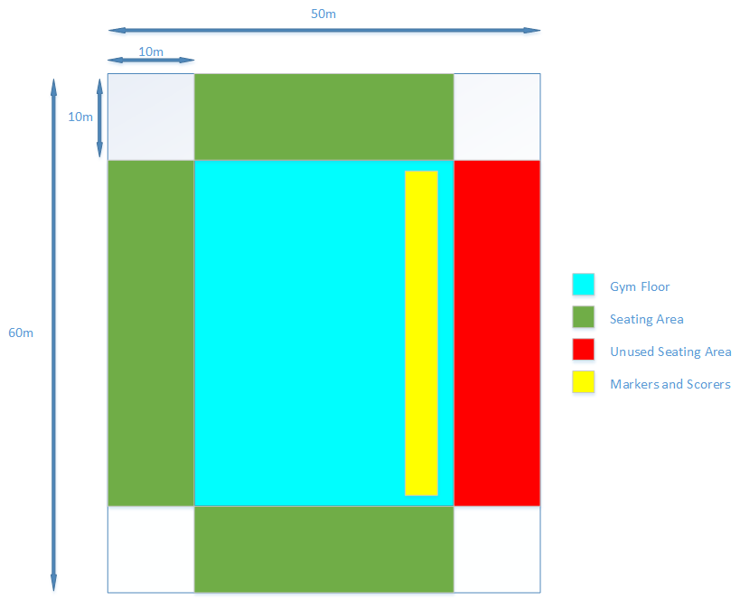

Figure . MATHEX competition layout at ASB Stadium

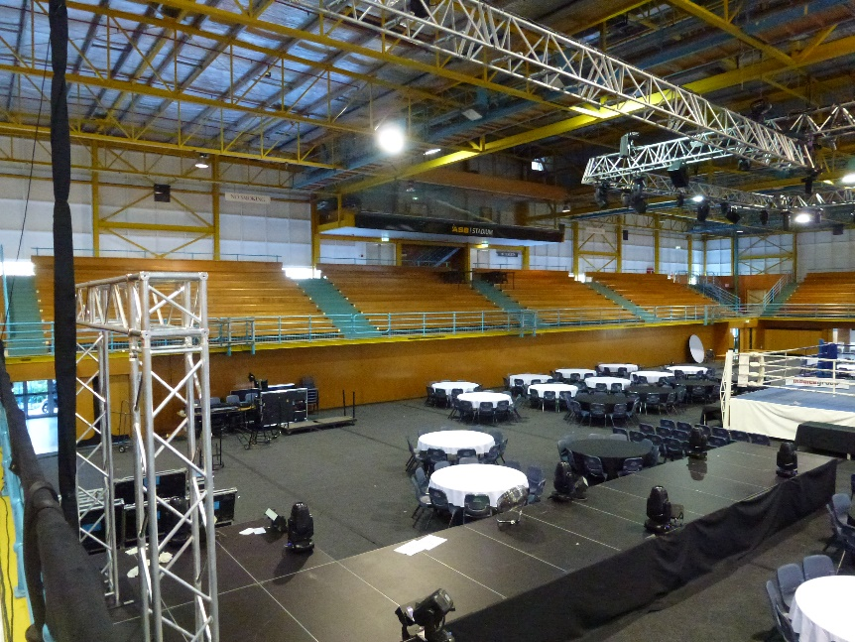

Figure . Unused seating section during MATHEX

### **Networks**

**Overview**

There are 2 Wi-Fi networks installed in the main gym area of ASB Stadium. The first network belongs to the stadium itself whereas the second network belongs to Selwyn College. Both networks have one access point each installed in the main gym (figure 3). According to Mr Tomlinson, both networks can potentially cover the entire main gym area.

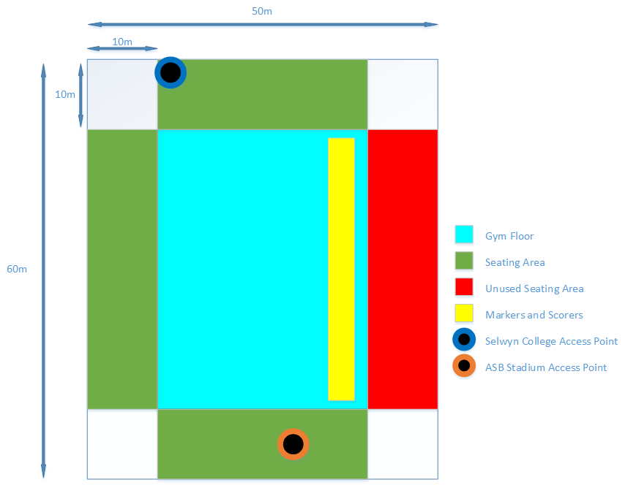

Figure . Location of Access Points in the main gym

**ASB Stadium network**

The ASB Stadium network is a broadband internet network. The access point is located under the seating area. There are other access points located in the stadium that are also connected to this network (e.g. reception area). A speed test of the network showed that the connection had 17 ping, 15 Mb/s download, and 12 Mb/s upload. Mr Tomlinson says that adding repeaters would extend the range to cover the main gym area. The stadium is open to us bringing our own equipment to install and utilise along with their network.

**Selwyn College network**

The Selwyn College network is a fibre internet network. There is one access point installed in the main gym area (figure 4). Permission to utilise the network would have to be requested from the Maths department of Selwyn College. There is no speed test data for this network.

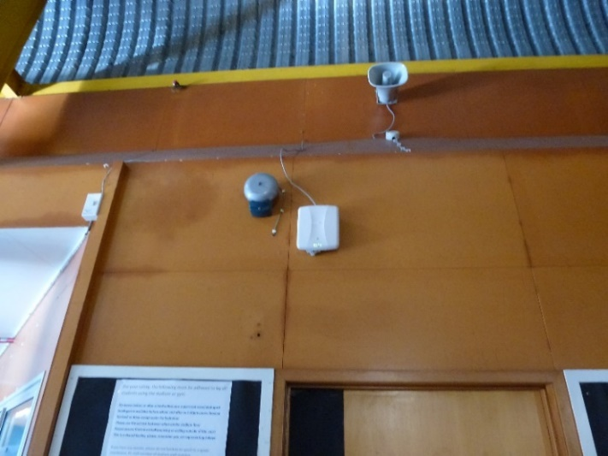

Figure . Access Point for the Selwyn College Wi-Fi network

### **Existing Equipment**

**Scoreboard Display**

There is no projector screen or other type of display installed in the main gym area. However, there is plenty of space to install a temporary screen and projector for a big scoreboard display. Mr Tomlinson recommends using a space in the unused seating section (figure 5) as it has been used in the past for similar uses. This location would be visible from most spots for spectators as well as competitors in the MATHEX competitions.

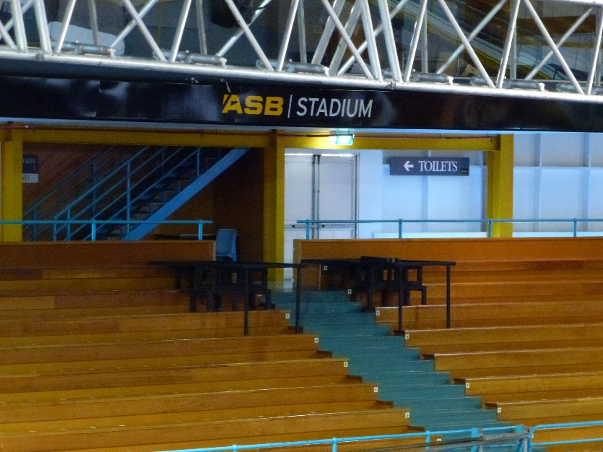

Figure . Recommended location for display

**Network and Server Equipment**  
There is no existing equipment such as access points, wireless repeaters, or servers that could be used for the Real-Time Scoreboard System implementation at the stadium.

**Further Research Areas**

Some of the areas that require further research include:

* The capacity and range of access points installed in the main gym.
* The type of equipment (if required) for extending the existing networks.
* Permission regarding the use of the Selwyn College network.
* Speed of the Selwyn College network.

## **Hardware requirements**

This section aims to evaluate the hardware necessary in order to host the application in a local environment. As there are many options available, our goal is to recommend adequate hardware to satisfy the client's needs.

It is crucial to understand that this research was undertaken as an individual component of the project, and it disregards any information about the venue’s current infrastructure such as networking or non-physical solutions, like a cloud-based system.

Any pricing provided was acquired through the research process on (23/05/17), all prices are subject to change.

The research was done based on the requirements of the system, see below:

* Project goal is to create a **real-time** scoreboard application or website.
* Can handle approximately 100 users (markers) updating the database simultaneously.
* Can handle at least 400 users (spectators) or requests simultaneously.
* OS was not specified as client required an open source system. AUT could also provide assistance with software.

*Please see* appendix A for *hardware specifications and quotation and appendix C for definitions.*

Solution 1

To host a back-end system for either a web-based-application or mobile phone application we recommend the system be divided into three servers: Reverse Proxy Server, Application Server, and Database server (please see figure 6 for a high-level network draft). For reliability and performance, it is recommended that you separate them (*see distributed system reference for more information*).

The use of a reverse proxy server would, among many other benefits, distribute the load from incoming requests. It will also protect against common web-based attacks such as DoS, DDoS, and malware. Additionally, it would reduce the load on its origin servers by caching static content.

The application server would be responsible for handling requests from the user or proxy server. It would inquire the database and provide results to the users, as well as handle all processing for each request.

The database is responsible for managing and storing all data of the application, and serving it back to the application server when requested.

Machine generated alternative text:
RESTful request 
Internet/ 
Response with ISON 
Application 
Figure 1 : 
Senaer Side 
Reverse Proxy server (NGINX Server) 
Application server 
(Tomcat server) 
Database server (Postgresql) 
Discussed framework 

Figure . Discussed Framework

Solution 2

A more compact solution that would also impact on the cost of the system is to utilise virtualization (*see virtualization in reference for more information*). The use of this strategy would allow us to co-populate two servers on one host. Essentially this means that one server would fulfil the role of two. In this case, the application server and the reverse proxy server will be in one server. This strategy eliminates the need of one of the three servers mentioned in solution 1. However, some enhancements could be required, such as a higher RAM capacity.

Beyond the cost benefits, using virtualization is a more efficient use of the processing power of a server. Taking into consideration that most of the requests will be **I/O bound** rather than **CPU bound**, the hardware recommended would not have issues with the demand (s*ee Requests-per-second in reference* *for more information*).

However, there is consequential reliability on the server in discussion, creating greater risks. For the same reason, we recommend that the database server is a separate system.

Solution 3

A simpler approach is to have one server that works as a database and application server, to eliminate the need for a proxy server. This is common practice for small applications or businesses.

This approach has several issues though such as slowness, no response at all, security issues, and a much higher risk of the entire system crashing. Therefore, we discourage this solution until the criticality of the system is fully assessed. System failure could lead to a major disruption in the competition.

### **Hardware specifications**

There is no simple or exact way to predict performance and scalability of a system. Each application and the environment it operates in is different. Programming languages, programs, Application Programming Interfaces (APIs), and functionalities all require a different amount of memory, processing power, internet bandwidth, and other resources as it also behaves differently.

The most accurate way to determine the correct specifications for a server or servers is to measure performance which will require the application itself or a prototype application to create a testing environment. Tests can be performed using virtual servers, load testing applications like "[JMeter](http://jmeter.apache.org/)", and application performance management tools, for instance [AppDynamics](https://www.appdynamics.com/) or [DynaTrace](http://www.dynatrace.com/en/index.html), to measure performance and identify bottlenecks. Only then, we can estimate what hardware specifications will suffice, without building an overzealous and unnecessary system.

For now, we have estimated what we believe would be required for the application to run and satisfy the requirements. However, these are only estimates.

Attention: prices are subject to change based on the parts' brand, type, quantity. There are several ways to achieve the same or similar specifications.

See **Appendix C** for definitions.

**Recommended Server Specifications:**

Database Server

HDD - 2 TB or more SSD enterprise grade in RAID set-up.

Processor - Intel Xenon processor that support Error Correct Code (ECC).

128 Gb (minimum) with ECC.

Reverse Proxy Server

HDD - 1 TB or more SSD enterprise grade in RAID set-up.

Two or more processors - Intel Xenon processor that support Error Correct Code (ECC).

128 Gb (minimum) with ECC.

Application Server

HDD - 1 TB or more SSD enterprise grade in RAID set-up.

Two or more processors - Intel Xenon processor that support Error Correct Code (ECC).

128 Gb (minimum) with ECC.

*Note: these estimations above were provided by "Akshay Raj Gollahalli".*

**What we have got a quote for (See appendix A for full description):**

Database Server

2x Intel Xeon E5-2620 v4 2.1GHz Processor, 8Core/16Thread ( Supports ECC)

8x 16GB (128GB)of Memory RAM ( ECC Registered)

Hardware RAID controller with 2GB flash backed write cache

2x 150GB SSD (RAID1 – OS/Boot only – 150GB Raw usable)

6x 960GB SSD (RAID10 – Database – 2.8TB Raw usable)

Write workload max: 3.6TB per day

Reverse Proxy Server

2x Intel Xeon E5-2620 v4 2.1GHz Processor, 8Core/16Thread ( Supports ECC)

8x 16GB (128GB)of Memory RAM ( ECC Registered)

Hardware RAID controller with 2GB flash backed write cache

2x 150GB SSD (RAID1 – OS/Boot only – 150GB Raw usable)

6x 480GB SSD (RAID10 – Hot Data – 1.4TB Raw usable)

Write workload max: 1.8TB per day

Application Server

2x Intel Xeon E5-2620 v4 2.1GHz Processor, 8Core/16Thread ( Supports ECC)

8x 16GB (128GB)of Memory RAM ( ECC Registered)

Hardware RAID controller with 2GB flash backed write cache

2x 150GB SSD (RAID1 – OS/Boot only – 150GB Raw usable)

6x 480GB SSD (RAID10 – Hot Data – 1.4TB Raw usable)

Write workload max: 1.8TB per day

We believe that the specifications of the servers quoted for are more than sufficient to satisfy the requirements, whilst also providing scalability for the future. However, due to the frequency of the MATHEX competitions, we recommend to purchase only hardware that will be used.

*Why are the specifications so high?*   
The requirements listed in the "Hardware Requirements" section and the recommendation provided above were used to inquiry for a quote. Our retail contact assumed that this is an enterprise-scale application, inferring that the servers will be running continuously with a constant 500 users or more. Therefore, the amount of storage memory is significantly high, it uses 2 processors and the memory matches the recommendations.

**What we think will be necessary:**

When assessing the current requirements, clearly there is not a significant amount of data that requires storage. For this reason, the database queries will be fast and simple. Also, the application should not perform complicated tasks that require heavy usage of the CPU. The challenge at hand is the hundreds of users using the application concurrently. Due to the powerful hardware available in the market, we believe that one server (Solution 3, see Hardware Requirements) should suffice. **See specifications below (See Appendix B for full description):**

Application Server \ Database Server

1x Intel Xeon E5-2620 v4 2.1GHz Processor, 8Core/16Thread (Supports ECC)

4x 16GB (64GB)of Memory RAM ( ECC Registered)

1x 150GB SSD (OS/Boot only – No RAID solution provided)

2x 960GB SSD (RAID1 – 960GB Raw usable)

(Excluded) ~~Hardware RAID controller with 2GB flash backed write cache~~

(Exchanged) ~~Supermicro 1028R-WC1RT Barebone~~

In this estimation, we have replaced the barebone as only one CPU is needed. Note there are four extra slots for memory to provide scalability. Also, excluded the CacheVault Supercapacitor as its extra protection is not necessary at this point.

Using this estimation, extra servers could be purchased to comply with the other solutions highlighted previously in the Hardware Requirements section. If this is the case, the specification above can be manipulated to reduce costs and adjust to the needs of the system application.

**Additional costs:**

Some other equipment may be necessary such as:

- Racks or cabinets to hold the servers

- UPS (Uninterruptible Power Supply)

**Other Elements of an in-house Implementation**

Along with acquiring the adequate hardware to satisfy the current requirements, there are other components which require attention. In many cases these are considered the drawbacks of purchasing your own hardware.

**Failure management - Disaster management**

It is important to plan for any events that may occur and affect the system performance. These events include; hardware faults, power outage, system overheating, and any natural disaster. Therefore, a disaster or recovery management plan would be necessary. However, such plans are usually the responsibility of the client to develop, this depends on whether the client determines that the information is vital, and that creating the plan is a necessity. The plan must also comply to the venue’s health and safety policies.

Common solutions are to have; the servers in a temperature monitored room, a fire suppression system in the event of a fire, a generator that kicks in automatically to supply power to the servers during an outage, back-up servers to take place when one stops working and daily back-ups of data, the list goes on, but these are the most significant regulations.

In the case of MATHEX competition, the current paper-pen system would not be discarded as the last resort back-up plan.

**Maintenance**

It includes regular hardware and software checks, to ensure the system is up to date and working as intended. The system may also undergo updates for bug fixes and adding features. Maintenance may also be extended to other parts of the system, such as the options mentioned in the failure management section above.

Further information can be found at: <http://sebokwiki.org/wiki/System_Maintenance>.

**Cost to run the equipment.**

We assume that the servers and its peripherical devices will not be located at the venue and will need to be moved from place to place, which will also infer set-up costs and tests.

Maintenance of the system will also generate costs as well as possible hardware faults.

**Durability**

A computer also has a lifespan, which is usually estimated between 3 to 5 years, but it is subjective. It will depend on how it is used, how often it is used, and how it is maintained.

There are many systems in existence that have been running for several years and will likely still live for many to come with the appropriate maintenance.

However, replacements of parts is to be expected, which will incur further costs.

**Cloud Solutions**

We have reached the conclusion that there are two different approaches we can take for a cloud-based solution for this project.

The first is a series of static web pages for all necessary components of the system. This includes; a small database and two or more webpages. The small database, consisting of one or two tables will store data. A user will access a web page which will send a request to the server, which pulls data from the database and displays it on the webpage. The markers will also be using a web page, but instead they will be sending requests for the server to transfer data into the database. To add security to the system, there is the option to include a login page for judges, otherwise they can be given a generated URL to access the pages privately.

This solution requires that data about the competition is collected, such as what teams and students who are participating. It may also be necessary to generate login credentials for judges to keep the database secure.

Technologies used for this solution are expected to be as follows:

* Amazon S3: Web hosting.
* Cloudflare: Web security and optimisation.
* Amazon RDS: Database Engine
* Languages Used: PostgreSQL, HTML and JavaScript OR Java (run on a Tomcat servlet).

The second solution would be to develop an application that displays on the web, this application would need to have the same capabilities of the first, but it would also include ways for administrators to set up competitions. This application will take up significantly more data on the cloud server, but it will also be a dynamic way to set up competitions, as the front end will provide controls to create custom leader boards.

Technologies used for this solution are expected to be as follows:

* Amazon EC2(T2): Web hosting
* Cloudflare: Web security and optimisation.
* Amazon RDS: Database Engine
* Languages Used: PostgreSQL, HTML and Java (run on a Tomcat servlet).

### **Web Hosting**

Web hosting can be thought of as having a high-tech computer, with a huge amount of storage space and processing power, all available through an internet browser. In reality, the web host already has all the necessary (and very powerful) hardware, they’re just letting you use it for a small price, and providing an interface for you to control it.

A web application is stored with the web host, and set up with a domain so that users can access the system. From there the web host handles all the data, requests and runs the software as it was designed. This solution is reliable, easily accessible and low-maintenance.

### **Amazon**

Amazon is a powerful and cost effective solution to web-hosting. It provides more computing power than any other online service and is completely free to join.

Amazon only charges for what you use, so setting up a small website will only cost cents per year.

S3 stands for Simple Storage Service. It provides an object storage to host cloud-based applications, websites, repositories and much more. It is designed to be fully scalable, boasts durability, a 99.99% uptime, easy to manage and fully integrated with a wide range of Amazon’s other web services.

EC2 provides a very similar service, but acts as a remote computer that can run software. EC2 is geared towards running applications, so the processing happens on Amazon’s side, rather than the user’s internet connection.

RDS is Amazon’s leading relational database system, it is a simple way to implement a database into an existing Amazon service and utilise it. A small database is free.

Amazon’s web services are unique because they are distributed worldwide, so users around the globe can access sites with improved latency. They are also unique due to their dynamic scaling – as soon as more storage or processing power is used, that is what you are charged for. Rather than most web-hosting services, which require you purchase the amount you need, and if you need more you must buy a set amount, and if you don’t use it all, well that’s just too bad because you’ve already paid for it.

All this information and more can be located at <https://aws.amazon.com/>

### **Cloudflare**

Cloudflare is like a virtual router for websites. It is a proxy server that filters malicious visitors, saves bandwidth and accelerates user connection to the website. Best of all, for a small website with low needs, Cloudflare is totally free!

Cloudflare increases the speed of a user’s connection by routing based on the user’s location, connecting them to the nearest datacentre in their location. Cloudflare also caches data on your website (temporary storage) so that when a user is loading up a page with the same images and code scripts, the data is all waiting in Cloudflare, rather than needing to be requested from the web host once again.

Cloudflare also reads a visitor’s IP to determine whether they are a threat to your website. Any detect threats are screened from the site and have no access to the site’s bandwidth.

All this information and more can be located at <https://www.cloudflare.com/>

### **Existing Solutions**

There has been a demand for custom leader boards, though nothing significant. After some research we found two suitable pre-made solutions.

AirScoreboard: <http://www.airscoreboard.com/>

An iOS exclusive app, for an affordable $0.99US. This solution allows users to create and manage leader boards as well as share them to various social media sites. It has a few additional features such as locations, languages, posters, and it has a way for ‘athletes’ to register themselves. A lot of these features are more than what is needed for the MATHEX scoreboard, and the iOS-only limitation is a large barrier.

Rise: <https://www.rise.global/pages/simple>

This site offers a large variety of leader boards, at what appears to be a commercial standard. It portrays itself as a visually-polished application and is available on web, mobile or on-screen (presumably one with ‘smart’ capabilities). While this is a great solution, there are no metrics to measure its reliability or security, it is not clear on the site whether they are using another web hosting service or have their own. Should this solution be explored, further information should be gather from a representative of Rise for this information before making a decision. There is an undeniably larger cost involved, at 14.99GPB (up to 100 teams) or 29.99GBP (up to 300 teams) per month. Though, it would only need to be up and running one month out of the year.

### **Estimated Costs**

Assumptions:

* 400 audience users, each making about 50 requests from the database over the competition duration.
* 100 markers, each making 100 requests to the database over the competition duration.
* Total storage of 500Mb or less.
* Data transfer in/out at 100MB/1GB per month at most.

|  |  |  |
| --- | --- | --- |
| Solution | Monthly Cost* | Yearly/Total Cost* |
| Solution 1 | $0.21 | $0.37 (per year) |
| Solution 2 | $3.33 | $12.41 (per year) |
| AirScoreboard | $0.00 | $140.89 (total – for 100 devices) |
| Rise | $27.65 | $27.65 (yearly, by cancelling after 1 month) |

*Currency converted to NZD 25/05/17 – this does not include conversion charges.  
  
Note that these costs only account for the running costs. There might be additional costs such as electricity, internet, hardware (for the network and devices for markers), etc. Those costs are difficult to estimate since they largely depend on other factors such as how the system is implemented.

### **Solution Summary**

The most feasible choice here is Solution 1 – a simple set of static web pages hosted on Amazon S3. Not only is this a cost-effective solution, that allows AUT to be branded alongside the AMA to encourage learning in New Zealand, it is highly achievable.

A simple site will not take an extended period to get up and running and ready for testing. This is ideal to ensure that the client gets to see an early prototype and have input on design decisions. The prototype will have plenty of time to be user-tested and presented to stakeholders part of the AMA.

It will also be very easy to build upon a simple site, to a full application in future, as the design decisions will have already been made.

Next up is between Rise and Solution 2. Both are supplying the same kind of functionality. However, Rise robs our group of the opportunity to develop anything, which we’re very keen to do. Solution 2, the Java application, will take some time to build, and may not have much time for testing. It is likely the prototype will be very basic and lacking a few features.

Solution 2 will be ideal to explore after the prototype of Solution 1 has been fully tested, it is unlikely that this will be undertaken by our group, unless outside of the Research and Development paper – the source code will always be available for anybody to build upon should they wish to.

Lastly, AirScoreboard is barely worth mentioning. It has a lot of ‘fun’ features, that are not necessary for the commissioned system, and it being a paid app exclusive to iOS puts massive limitations on it. The judges would each need to have an iOS device to log scores, which is not at all feasible.

System Implementation

**The Infrastructure**

Based on the current state of the venue, it is expected that additional equipment will be required to provide access to the wireless local area network for all MATHEX attendees. Both existing networks at the stadium have just one access point in the main gym area. More access points and repeaters would be needed to extend the range and capacity of the networks to accommodate for the MATHEX competition attendees. Moreover, depending on the choice of application solution and system implementation, the existing internet connections may not have sufficient bandwidth to handle the amount of traffic. In this case, solutions with the internet service provider will need to be explored. Note that this will likely be at the expense of the venue for any potential upgrades.

On the other hand, there is also the option of internet access through the user's own data plan, which will be at their own cost. This isn’t ideal as only a limited number of users would be able to access the system. Note that this is only applicable for a cloud based approach.

As a reminder, because the MATHEX event could take place in different venues in the future, the full assessment of the venue is not our main focus.

**Purchasing the Hardware**

The benefit of having all the servers at the same location where the MATHEX event occurs is that there is no need for internet access. The presence of a Wireless Local Area Network (WLAN) would satisfy the needs to run the application and connect all the users present at the event.

However, the equipment costs can be very high. There are also potential future costs such as: the set-up of the system, transferring the server location, maintainability and labour. Additionally, a disaster management plan may be required to comply with venue's policies and general health and safety regulations, as well as to keep the data backed up and stored, and keep the competition running.

MATHEX events are infrequent. As we understand, those servers and any other equipment would not be used for the rest of the year which would could lead to waste of resources. The equipment will also need to be stored at someone’s expense, and be insured if it is damaged, misappropriated, or lost for any reason.

The MATHEX events seem to be increasing in popularity and attendance each year. It may not always be feasible to accommodate for all users present at the event as the hardware would have limited scalability. It may require new hardware components or servers, replacements of old parts, and new technology. To conclude, adding more capabilities to the system reapplies all the risks of implementing the system in the first place, costs will need to be calculated each time and will most definitely increase.

Therefore, we believe that purchasing and maintaining your own servers for this particular solution is not cost effective and is a misuse of resources.

**Using Cloud Solutions**

Using cloud solutions will require internet access, which means the internet bandwidth must support the traffic of data otherwise users will experience slowness when using the application.

There are different cloud services available, but many of them allow you to pay as you go, meaning you are only charged for what you use. With this feature, there is a significant reduction in costs, as the application and the resources necessary can be reserved whenever they are needed and paid accordingly. Furthermore, it eliminates any need or concern for servers. Their location, status, storage, maintenance, and all other concerns listed above are of no consequence to the developers, client, venue, or any other stakeholders. The companies that provide these services are responsible for their hardware and software.

In case the number of users increases, more resources can be purchased with ease. In some cases, cloud providers may adapt automatically and charge accordingly.

It is evident that using a cloud service will be significantly cheaper than purchasing your own hardware. It will eliminate many headaches, and can be used at any place and time as long access to internet is available.

Note: It could be of the client’s wishes to purchase the hardware, if they are not readily available in AUT. The same system could be maintained at AUT's grounds and be provided over the internet. This approach would work over the internet similarly to the Cloud approach.

**The Technology - Conclusion**

After our assessment, we have concluded that the best option for the implementation of an application that satisfies the client's requirement and reduces short and long term costs is the use of cloud technologies.

It does not mean that Cloud services is better than having your own hardware but for this specific purpose the benefits of using cloud services instead surpasses the benefits of buying hardware.

As students plus the contribution of our lack of experience, we believe that the set-up of the servers will be complex and therefore, we cannot commit to the reliability of the system. On the contrary, using a system already set up for us provides a higher chance of success.

**Application Solutions**

In this section, we would like to emphasize potential applications which aim to fulfil the project scope. We concentrate our discussion on what they are, and why or why not they should be considered. We have identified three ways the application can be built; web-based application, mobile device application and a computer application. We list them below.

Web-Based application:

**What:** It is an application which runs in a web browser.

**Why:** Because any computer or mobile device, using any operation system such as Windows, Linux, Android, or iOS, can access and use the application as long as there is access to the internet (or the network where the app is hosted) and a web-browser capable to surf the internet. This is the most universal approach compatible to all devices.

Mobile phone application:

**What**: it is an application that runs on mobile devices, smart-phones or tablets.

**Why:** The great majority of people have at least one type of mobile devices in New Zealand. A mobile phone application are usually more user friendly. It is easier to access and the user interface is easier to interact with.

**Why Not:** There are several types of mobile phones and tablets which increases the complexity of creating an application but it gets more complicated when we look at their operating systems. The most common ones are Android, IOS and Windows and therefore supporting all operating systems may not be feasible.

Furthermore, to use an application in a mobile device it must be downloaded and installed first. Usually an application is considerably large. To download the application, users must have access to the internet or download it before coming to the MATHEX competition. Otherwise, having hundreds of people downloading at the same time using the same network will result in the network becoming slow, hence generating delays for the scoreboard system.  
  
Lastly, because uploading the app to the device’s respective app store would incur additional fees, it will need to be downloaded from an unauthorised location, which many users may not trust.

Computer application (Physical Scoreboard):

**What:** A desktop application that runs in a computer. This approach would not be available to the spectators but only to the markers so the answers can be entered. The score board would be mirrored to a screen(s) through a projector positioned such that spectators can view the scoreboard .

**Why:** The aim of this solution is simplicity. It would reduce significantly the amount of resources needed such as powerful servers, internet access and Wi-Fi connection for spectators. Due to the low traffic of data one computer could take over all the work that needs to be done ( See Solution 3 of hardware requirements section). The most important part of this solution is setting up a project\screen at the venue. However, the simplicity of this solution may not satisfy all client's requirements. Further costs are expected for implementing a projector and screen.

**Why Not:**  There is a high risk that implementing a scoreboard using a projector will not solve the problem. It is possible the spectators will have problems seeing the screen's content . Also, only the top teams will be shown on the screen unless a different solution is provided. At this stage, this approach does not add any considerable value to the MATHEX competition instead more complications.

Note: The application used by the judges to enter the answers is not defined here. It could be a mobile app, an web-page or another computer application.

**The Application - Conclusion**

Based on the assessment above, the Web-Based application solution is the best option that satisfy the project scope. It is simple to use and requires no installation for users. Also, it facilitates implementation due to its universal framework.

# **Operational Assessment**

The operational assessment aims to cover and answer the following issues about the new system and its different approaches:

* **Process:**How the users will benefit from the new system and its processes. There are three main users: spectators, markers/scorers, and the judge. However, the focus will mainly be on the spectators as different approaches do not affect other users.
* **Implementation**:  How much time, cost and/or other resources each approach will use as well as their physical implementation in the competition’s venue.
* **Evaluation**: Whether the system can work and cover key goals covered in the project scope.

## **Hardware (Original) and Cloud Approach with Web-Based application solution**

The original approach allows users to see a real-time scoreboard of the competition using their portable devices. It will use a custom server to allow users to connect to it and allow them to fetch and update information.

The cloud approach functions similarly to the original but uses the internet and cloud servers instead of a physical server.

**Process**

The spectators stand to see the most benefit from this approach. They will be able to search for and track specific teams as well as the rankings for the entire competition. While these approaches are the most beneficial to spectators, it is restricted to spectators with smart devices.

The cloud approach has similar benefits but is limited by the bandwidth and capacity of the networks located in the competition’s venue.

**Implementation**

The cost of the server as well as the time it takes to develop the spectator and judge application makes this approach easily the most expensive. As for other issues with implementation such as the location of the server in the competition, these are almost negligible or easily mitigated.

The cloud approach significantly reduces the cost of the implementation. The limited bandwidth and capacity of the internet access points can be mitigated by the implementation of 4G/LTE modems in the venue.

**Evaluation**

The original approach solves the problem of spectators being unable to see the competitions standing. Furthermore, it allows the users to track specific teams. The system’s hardware will be able to set up a local Wi-Fi network and should be able to set up the Real-Time Online Scoreboard from any location. Overall, the original approach will take the most resources out of all approaches to accomplish but should be able to cover all aspects of the scope.

The cloud approach similarly solves the main problem of spectating the competition but may be hindered by technical issues. In addition, it can only be set up in an area with a somewhat strong internet connection. Overall, the main functionality of the system covers the main scope for spectators however it does not meet the requirements of readymade hardware capable of setting the system up without an internet connection.

## **Physical Scoreboard with and without Cloud**

This approach replaces the user connecting to a server to view a scoreboard on their devices and instead uses a physical live scoreboard that will be placed in view of the spectators at the venue.

**Process**

While the spectators will be able to see how teams are faring in the competition, the ability to track specific teams will be removed. It will also be more limited as not every team will be able to be shown due to size constraints. An additional component to automatically scroll through the scoreboard will have to be introduced to compensate. Furthermore, the scoreboard may affect teams of the competition. This approach, however does have an additional benefit in that all spectators will be able to view the scoreboard and is not limited to smart devices.

**Implementation**

Similar to the approaches above, there is a custom hardware or a cloud approach. The time and cost constraints are also similar. The hardware approach will cost much more to develop. The physical scoreboard’s location and size may also be an issue.

The cloud approach costs less and because users do not have to connect to the access points in the stadium, this approach is less hampered by capacity and bandwidth issues. In addition to this, this approach will take significantly less time overall to develop as there will be less to develop for the spectator’s side.

**Evaluation**

This approach does allow spectators to view the standings in the competition but specific team tracking must be accomplished by either waiting for the scoreboard to scroll or by searching the paper scores for a specific team. Depending on the approach, the system may also be able to be implemented into a hardware solution but the additional need for a physical screen hampers its portability. Overall, this approach has the least amount of benefits to the spectators compared to the other approach and only covers the basics of the scope. However, it is the most feasible of the approaches and takes the least amount of time and cost to develop and implement.

## **Scorer Option**

The system does not benefit the markers and it may even hinder those that are not adept at handling technology. In addition, the cost of supplying a device to each judge is very expensive. An option to get around this is to have the scorers at the competition handle updating the system instead of the markers. This will eliminate the above disadvantages of the system as well as decrease costs of supplying and training the markers.

However, this may raise an additional concern. There are less scorers to update the system which may cause inconsistency in the scoreboard. A solution is to simply increase the number of scorers.

# **Legal Assessment**

The Legal study covers over all legal aspects of the project and aims to verify that the project meets government laws and safety standards. This study focuses on two specific areas: the ASB Stadium Sports Venue where the Casio MATHEX competition takes place and the Open Source Licenses that may be used in the project.

**ASB Stadium Sports Venue**

The stadium has its set of Terms and Conditions that must be closely adhered to. This section will focus on the most relevant terms and conditions to the project.

* “**10.5** The hirer will not make nor allow any alterations or additions to any part of the venue or install any electrical or mechanical device without first obtaining the approval of the ECCT.”
* “**10.9.** Any electrical devices used at the Venue must comply with the appropriate standards. The hirer will indemnify the ECCT against any loses which occur as a result of the use of electrical equipment that does not meet the terms and conditions or the appropriate standards”. (EECT Stadium General Terms and Conditions V2.0 (2017). *East City Community Trust Board*, Section 10: Use of the Venue)

This section means that approval will be necessary if modifications to the venue become crucial for the project to succeed. We will also need to make sure that all hardware meet safety standards and regulations. In addition to this:

* “**10.8.** The hire area must be reinstated by the hirer at its sole cost to at least the condition it was in immediately before the hire period. All reinstatement must be completed within the hire period after which time the ECCT reserves the right to complete reinstatement on the hirer’s behalf and at the hirer’s cost.”.  (EECT Stadium General Terms and Conditions V2.0 (2017). *East City Community Trust Board*, Section 10: Use of the Venue)

If modifications are made to the venue, then we will need to revert these changes after the competition is held. This could mean that significant costs could occur before every competition if it is necessary to modify the venue to implement the project.

The terms and conditions also state that any damage, loss, claim, cost, liability or expense will be our own responsibility should the project fail in any way.

(EECT Stadium General Terms and Conditions V2.0 (2017). *East City Community Trust Board*, Section 15: Exclusion of Liability)

EECT is the East City Community Trust Board. It is made up of three members mainly: Selwyn College (Ministry of Education), ASB Stadium Sports Club and the Community.

**Licensing**

For licensing, we have decided to choose the route of open source licensing rather than a closed source. This is because we want future teams to be able to access our work in the case the project cannot be completed by our team as per the client’s requirements. The open source license that we are leaning towards is the GNU Affero General Public License (AGPLv3). This is the strongest leftmost license which will ensure that all future modifications or versions of the software will follow the same conditions and have the same permissions. Additionally, per the full text of AGPLv3, this license is specifically designed to ensure cooperation within the community in case of network server software. As our project is a network server software, this will prevent problems where the software source code is not accessible due to being run on a server.

**Open Source Requirements**

Since we are using Open Source licenses, our project will be subject to a few requirements and conditions to preserve the provenance and openness of the software being used. Listed below are the general conditions and limitations the project may have to follow:

* **“Disclose Source:** Source code must be made available and public for anyone to see.”
* **“License and Copyright notice:**A copy of the license and copyright notice must be included somewhere within the project code.”
* **“Warranty Limitations:** The license explicitly states that it does not come with warranty.”

(Licenses | Choose a License. (n.d.) *GitHub, Inc*)

Open source licenses also come with permissions which allows to do the following with the project:

* **“Commercial Use:**Allows us to use the project commercially.”
* **“Distribution:**Allows us to distribute the software to others.”

(Licenses | Choose a License. (n.d.) *GitHub, Inc*)

# **Resource and Schedule study**

Our schedule indicates there is a period of approximately three months to develop an application that meets the client's request. Throughout this period a prototype could be developed and tested along with the client's approval. By the time the application is ready to be tested live, there will be no MATHEX competition scheduled and there is still the possibility the implementation system of choice is not available yet. Therefore, we have not looked at the opportunity to test the application during the MATHEX competition as it happens once a year and the application as well as the system to host it will not be ready.

The reason to develop a prototype is to showcase all the functionalities that will be used during the competition and ensure that it will be well accepted by the stakeholders. This application prototype will then be opened for improvement. There will be no need for the client to acquire any of the implementation solutions. The development will happen independently and can be demonstrated using minimum hardware.

Therefore, to proceed with this project aiming to have a working solution within the time available is not time feasible. As there is not enough time to develop an application which solves the problem and add value to the MATHEX competition, nor there is enough time to have it implemented and ready to be used. Additionally, the system to be implemented will not be tested during the MATHEX competition, missing on important feedback from the main users who are the spectators, markers, Scorers and judges.

**Schedule**

Our schedule for building a prototype:

|  |  |
| --- | --- |
| Provisional Milestones | Finish |
| Stage 0 | 28/07/17 |
| **Plan - design of project model complete** | 28/07/17 |
| Stage 1 | 11/08/17 |
| **Framework and Database setup complete** | 11/08/17 |
| Stage 2 | 25/08/17 |
| **Website development complete** | 25/08/17 |
| Stage 3 | 22/09/17 |
| **Website integration with database completed** | 22/09/17 |
| Stage 4 | 06/10/17 |
| **Online Real Time Scoreboard implementation complete** | 06/10/17 |
| Stage 5 | 20/10/17 |
| **Website UX\UI improvement complete** | 20/10/17 |
| **Handover Complete** | 27/10/17 |
| Client feedback | 29/09/17 |
| Supervisor feedback | 20/10/17 |
| Poster | 3/11/17 |
| Reflective Report | 3/11/17 |
| Portfolio and Final Product | 3/11/17 |

**\*\*\*Please see the complete Project plan for further details**

**Conclusion**

The conclusion of our study points the project is not feasible. To elaborate on our final conclusion, we have assessed the three main elements: scope, time, and cost. We have also taken in consideration the resources available to produce a system the satisfy those three elements and evaluate the technical difficulties that may extend this project beyond the schedule.

Scope,

Time,

Cost,

Evaluation of resources,

Students, we, can upskills only some much. The people who will work on the project are the most valuable resource. The team should be evaluated to ensure that the right people are available at the right time.

Too many technical difficulties,

How much risk contingency can the organisation handle? How much is the organisation willing to invest in the startup so that the project can eventually bring a return on investment?

Too many stakeholders involved,

Project could be further extended to solve client’s problem and MATHEX problems

Recommendation

A prototype software to showcase all the functionalities that will be used during the competition and ensure that it will be well accepted by the stakeholders. This application prototype will then be opened for improvement. There will be no need for the client to acquire any of the implementation solutions. The development will happen independently and can be demonstrated using minimum hardware.